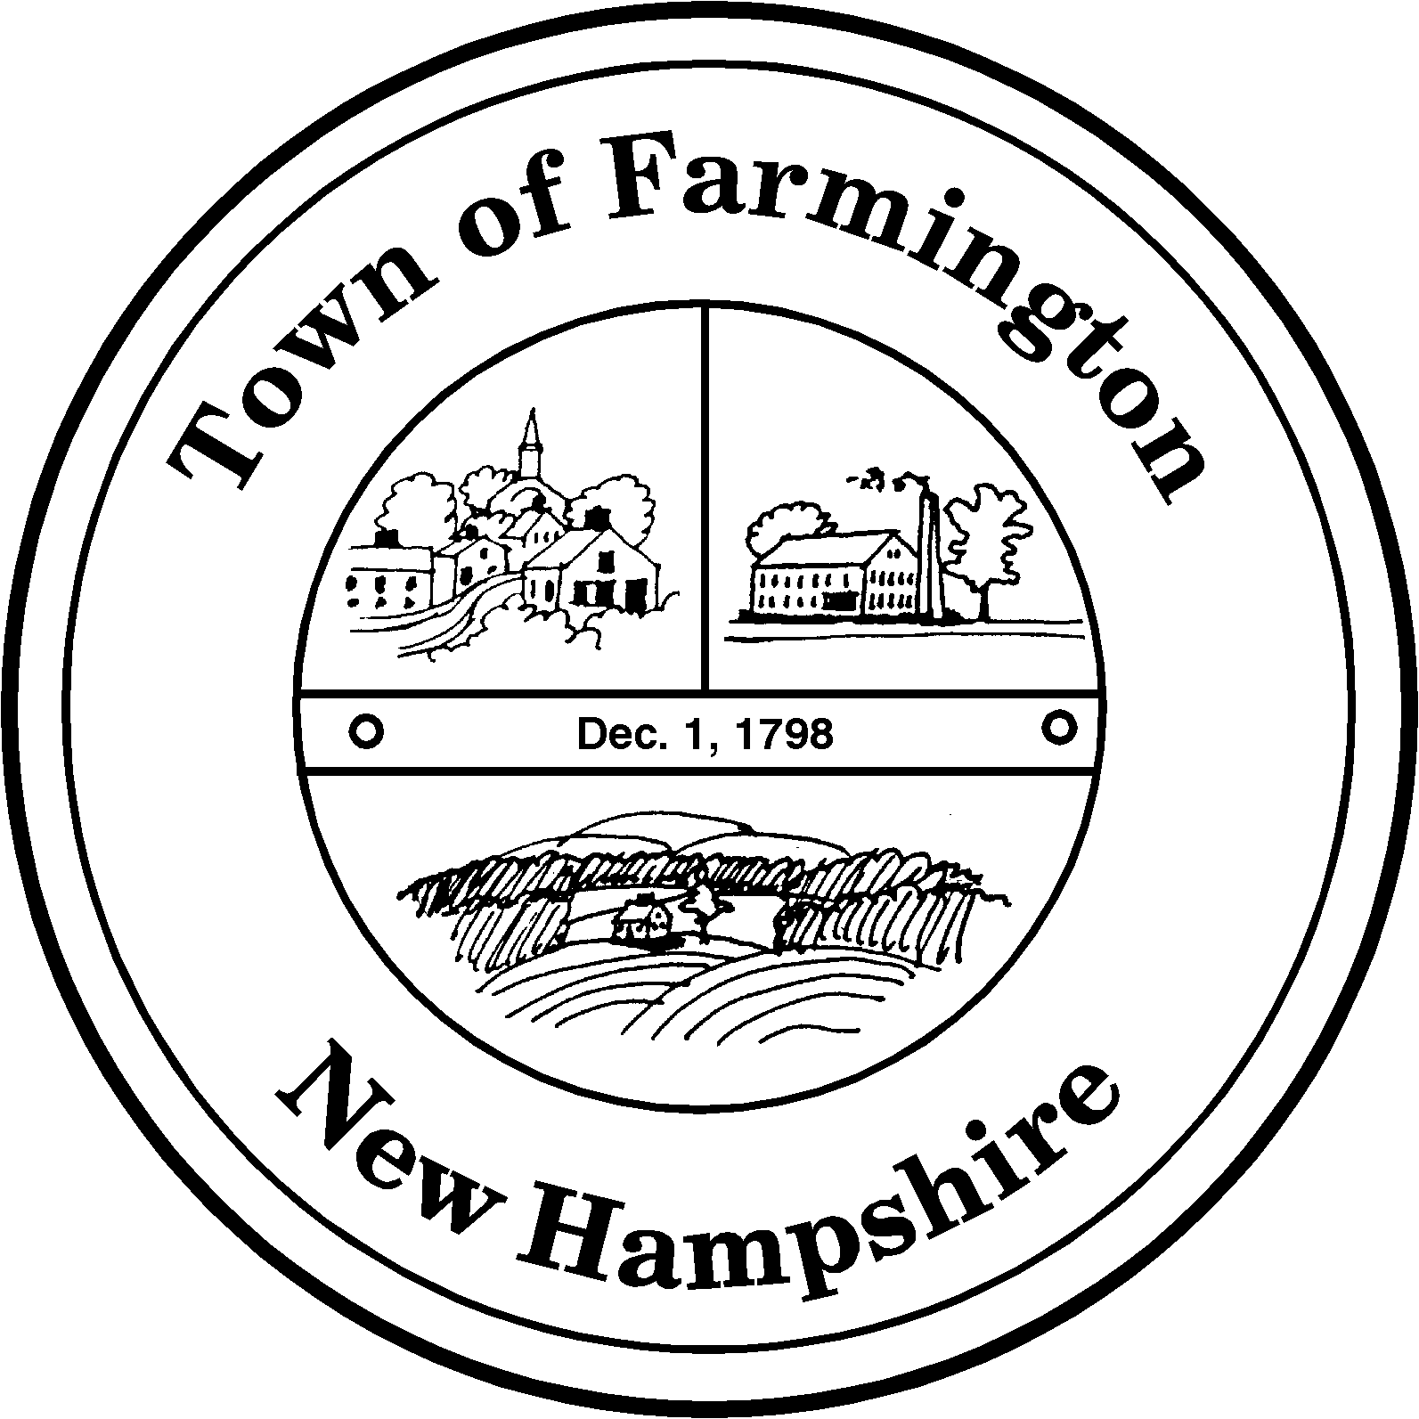
Town of Farmington
Planning and Community Development
356 Main Street
Farmington, NH 03835
Phone: (603) 755-2774
A Bicentennial Community
1798 - 1998

PLANNING BOARD WORKSHOP MEETING

TUESDAY – November 01, 2011

356 Main Street - Farmington, NH

AGENDA - 6:00 p. m.

BUSINESS BEFORE THE BOARD:

- Pledge of Allegiance

- Review and Approval of Minutes of October 18, 2011

- Update on Grandfathered Status of Malcolm Bradsher Excavation Site – R-14 Lot 12

- Update on the Pike Industries Paulson Road site – R-35 Lot 7

- Haycock – Estimate for engineering review

- Discussion regarding Coppola application (R-20 Lot 7) – to determine if a variance is necessary where a Special Use Permit is required.

- Discussion regarding proposed Zoning Amendment – Small Wind Turbines

- Discussion regarding proposed Zoning Amendment – Housing Maintenance and Occupancy Code

- Any other business to come before the board.

PUBLIC HEARING 6:30 P.M.

2nd Public Hearing - Proposed Amendment to the Planning Board’s Rules and Procedures to Adjust Abutter Notification Fees.

2nd Public Hearing - Proposed Amendments to the Town of Farmington Excavation Regulations and Application to Delete References to Renewal Process and Renewal Permit.

Paul Parker, Chairman,

Farmington Planning Board

